/*Ashok IPBC SSRS Practice Lab 7.18.19*/

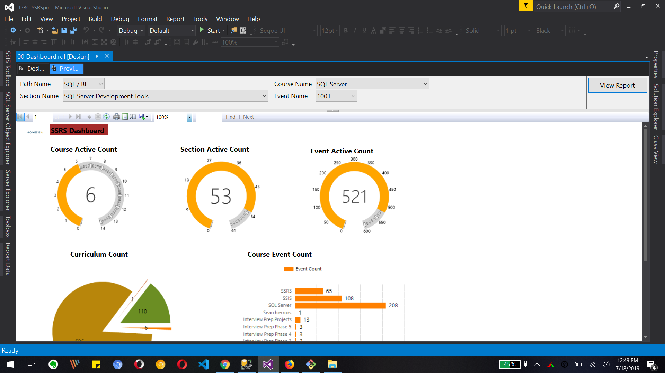

The above dashboard shows Logo and title with two different subreports inside 1. Guage reports and 2. Pie chart and Barchart. We can also see parameters on the top of the report.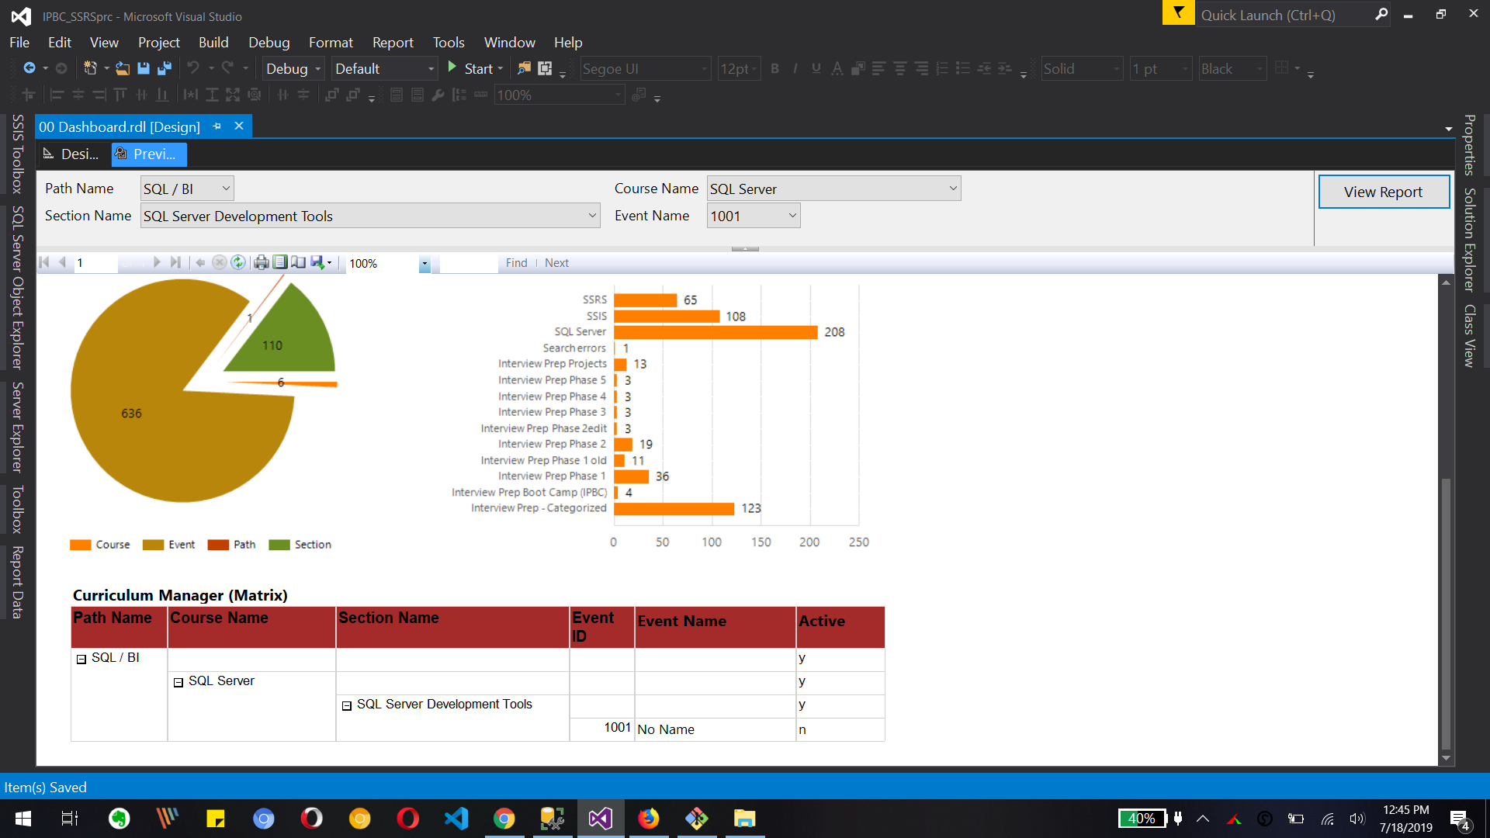

Now in above image we can see 3. Matrix drilldown report for selected parameters.

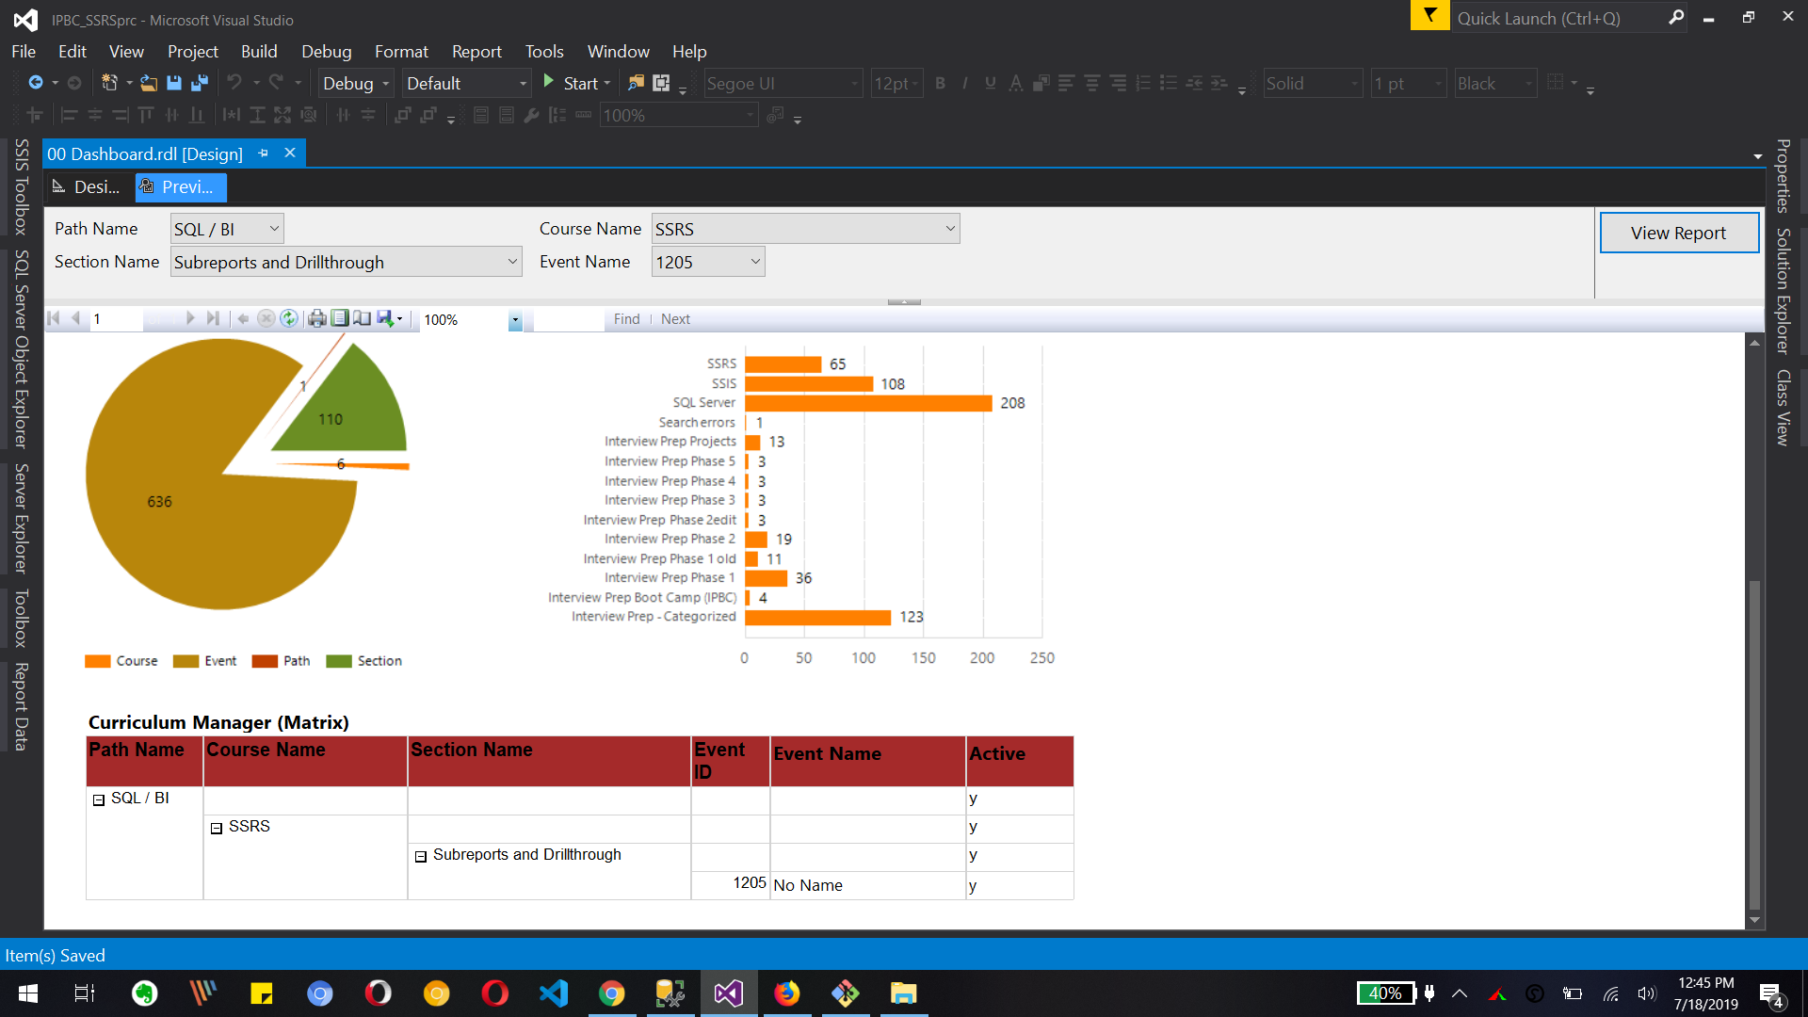

The above report’s focus is on cascading parameter change and drilldown report changes. We have changed parameters selection so we can see that change in drilldown report too.

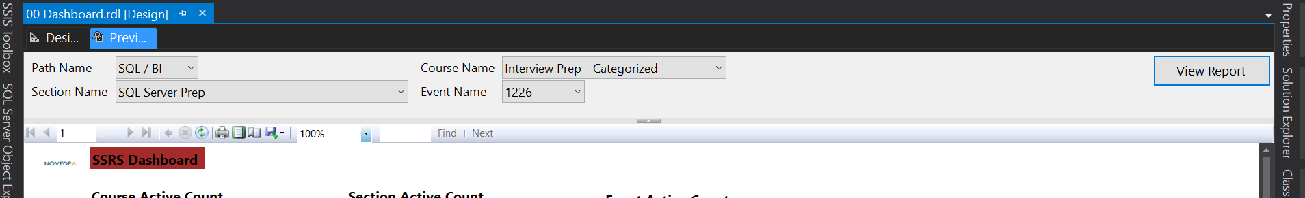

The change in parent parameter will change the child parameter value as part of cascading parameter.

**What to Submit:**

1. Copy and paste the link to your video(s) as part of your homework.

<https://app.colaberry.com/app/ipbc/videos?user=31221&category=41>

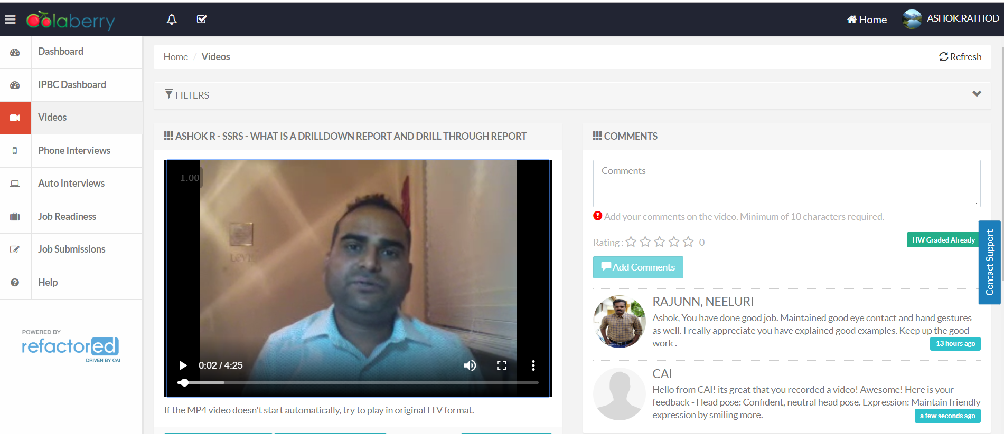

2. Watch, Comment &amp; take screenshots of your comments from 3 other videos on the same topic (per question). Comments must be 20+ characters. Leave comments based on presentation, delivery and/or technical details. Your critiques will help you be more conscious of your own videos. (3 comment screenshots per Video Question)

